PixelPals – MVP Systems Testing Report
Tester: Joel
Module: CS2TP
Team: PixelPals

1. Introduction
This report documents the system testing performed on the PixelPals MVP. The purpose of testing is to verify that all core pages load correctly, frontend functionality behaves as expected, and backend form submissions reach the appropriate PHP files via XAMPP.
The aim of the tests is to:
- Navigation: Ensuring all internal links correctly route to the intended HTML pages.
- Data Transmission: Confirming that user input from the Login, Registration, and Contact forms is successfully sent via POST requests to the corresponding PHP scripts.
- UI/UX Consistency: Evaluating the visual layout of Product and Checkout pages across supported web browsers.

2. Test Environment
• Operating System: Windows 10/11
• Browser: Microsoft Edge/Brave
• Server: XAMPP (Apache)
• Execution Method: Localhost testing via http://localhost/pixelpals-mvp/

3. Test Cases
Each test case includes steps, expected results, actual results, and pass/fail status.

TC1 – Navigation Bar
Steps: Open each navigation link.
Expected: user should be able to navigate different pages by clicking on the desired page.
Actual: Navigation to the different pages was successful.
Status: Working
Screenshot: N/A

TC2 – Login Form Submission
Steps: Enter email + password, click Login.
Expected: login.php receives POST.
Actual: login.php has successfully received POST but the browser displayed the actual php text code instead of executing it
Status: Working
Screenshot:
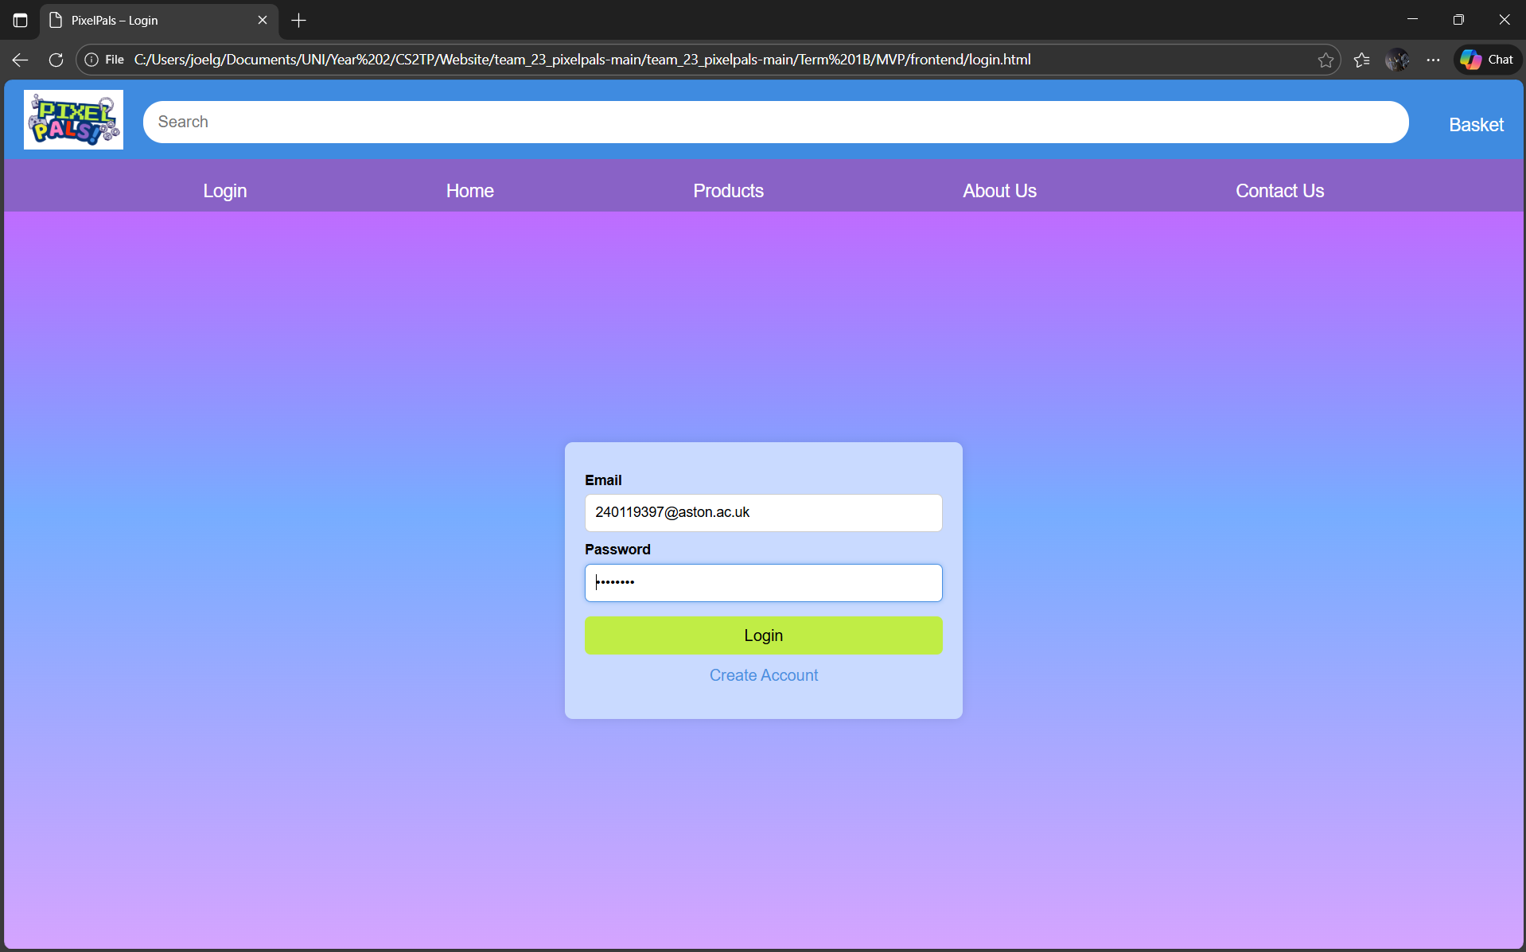
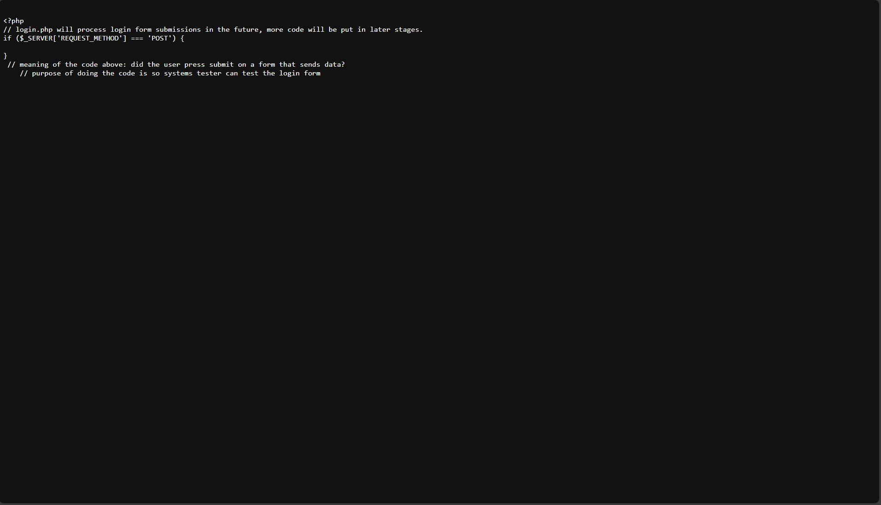

TC3 – Registration Form Submission
Steps: Fill all fields, click Register.
Expected: registration.php receives POST.
Actual:
Status: Working
Screenshot:

TC4 – Registration Form Submission
Steps: Fill all fields with mismatching passwords, click Register.
Expected: registration.php receives POST.
Actual: registration.php has successfully received POST but the browser displayed the actual php text code instead of executing it
Status: Working
Screenshot:
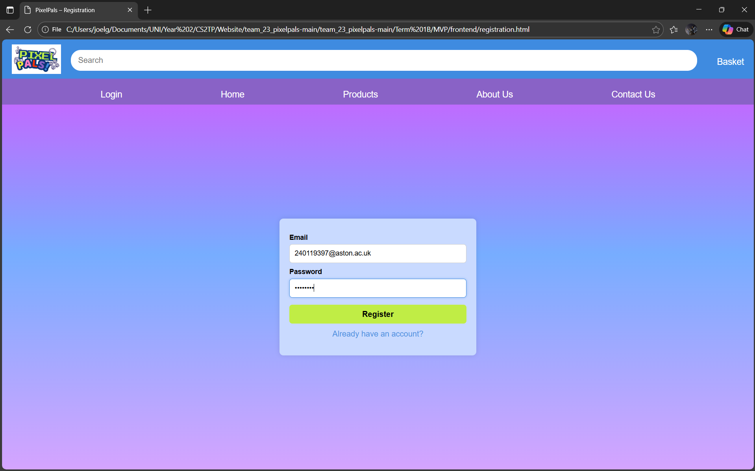
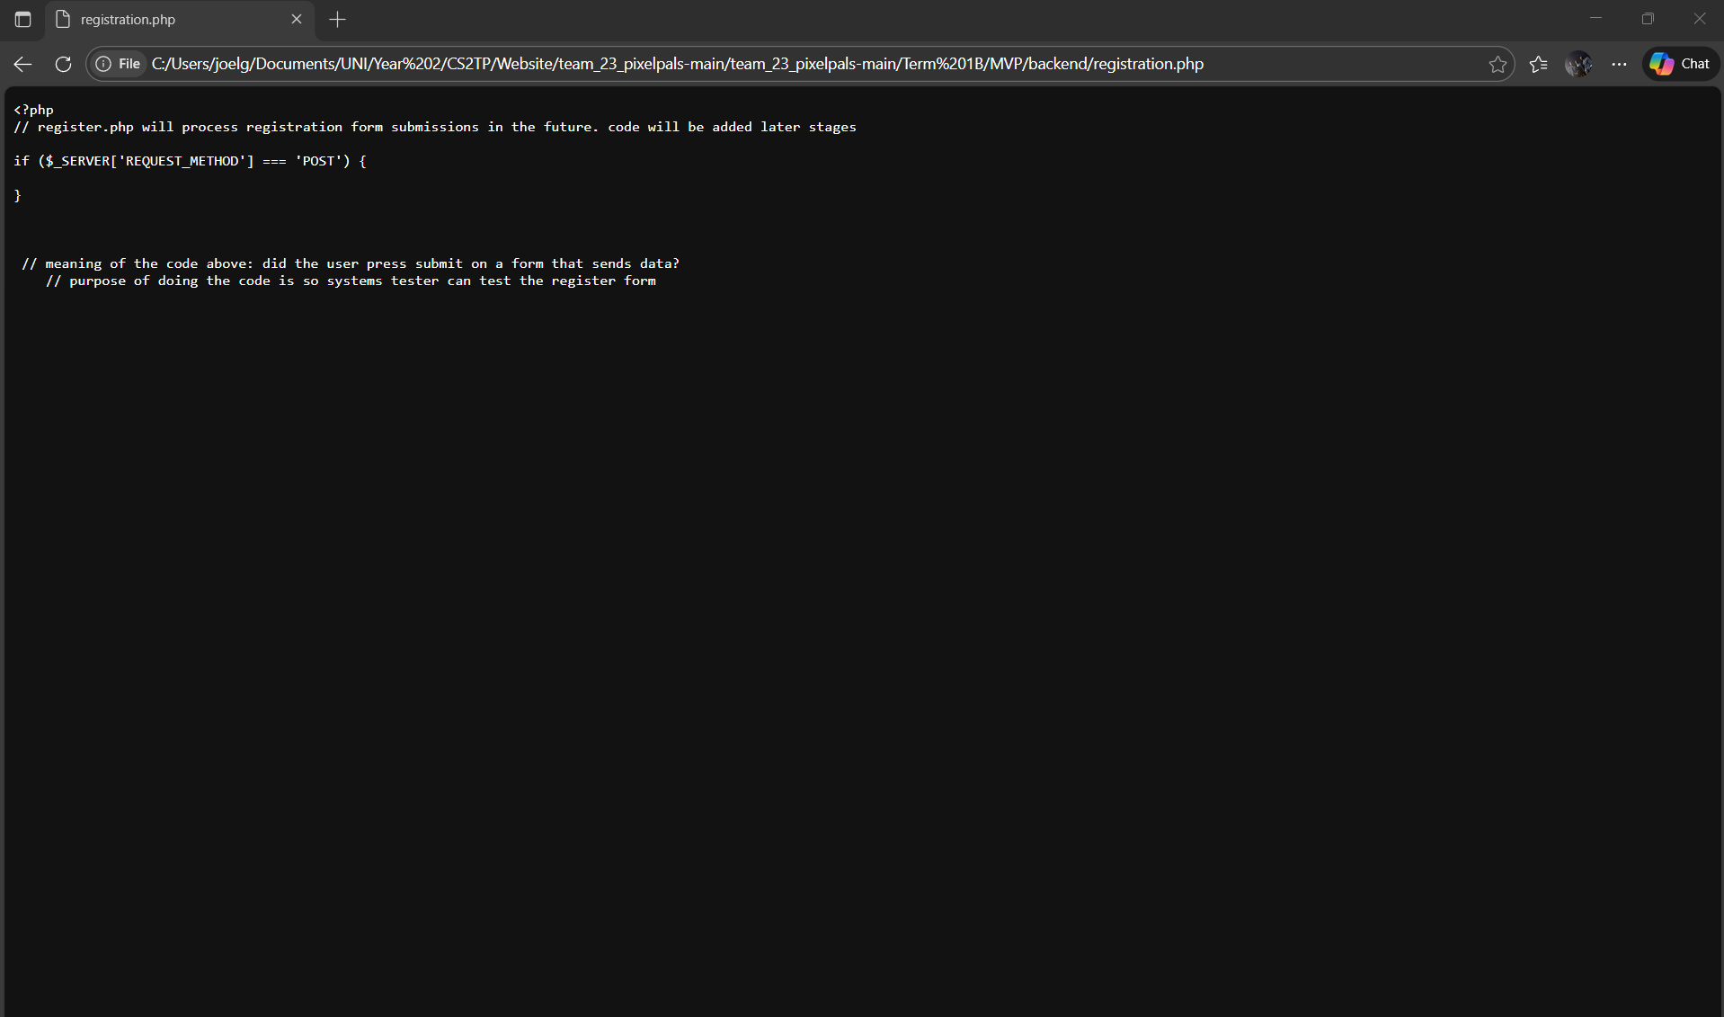

TC4 – Contact Form Submission
Steps: Submit name, email, message.
Expected: routes.php receives POST.
Actual: has successfully received POST but the browser displayed the actual php text code instead of executing it
Status: Working
Screenshot: 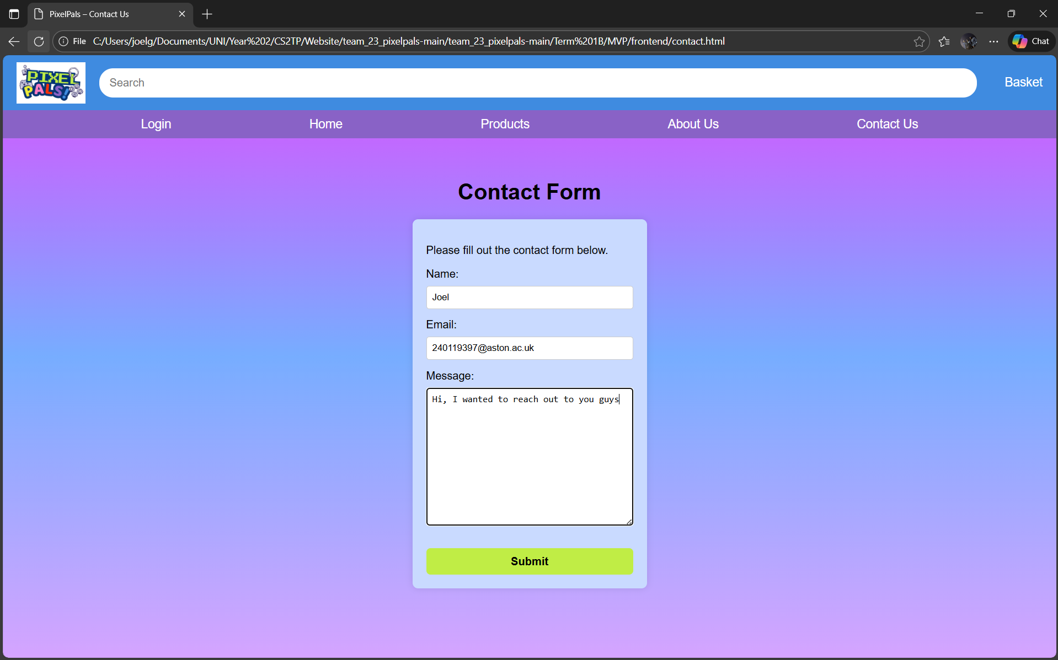
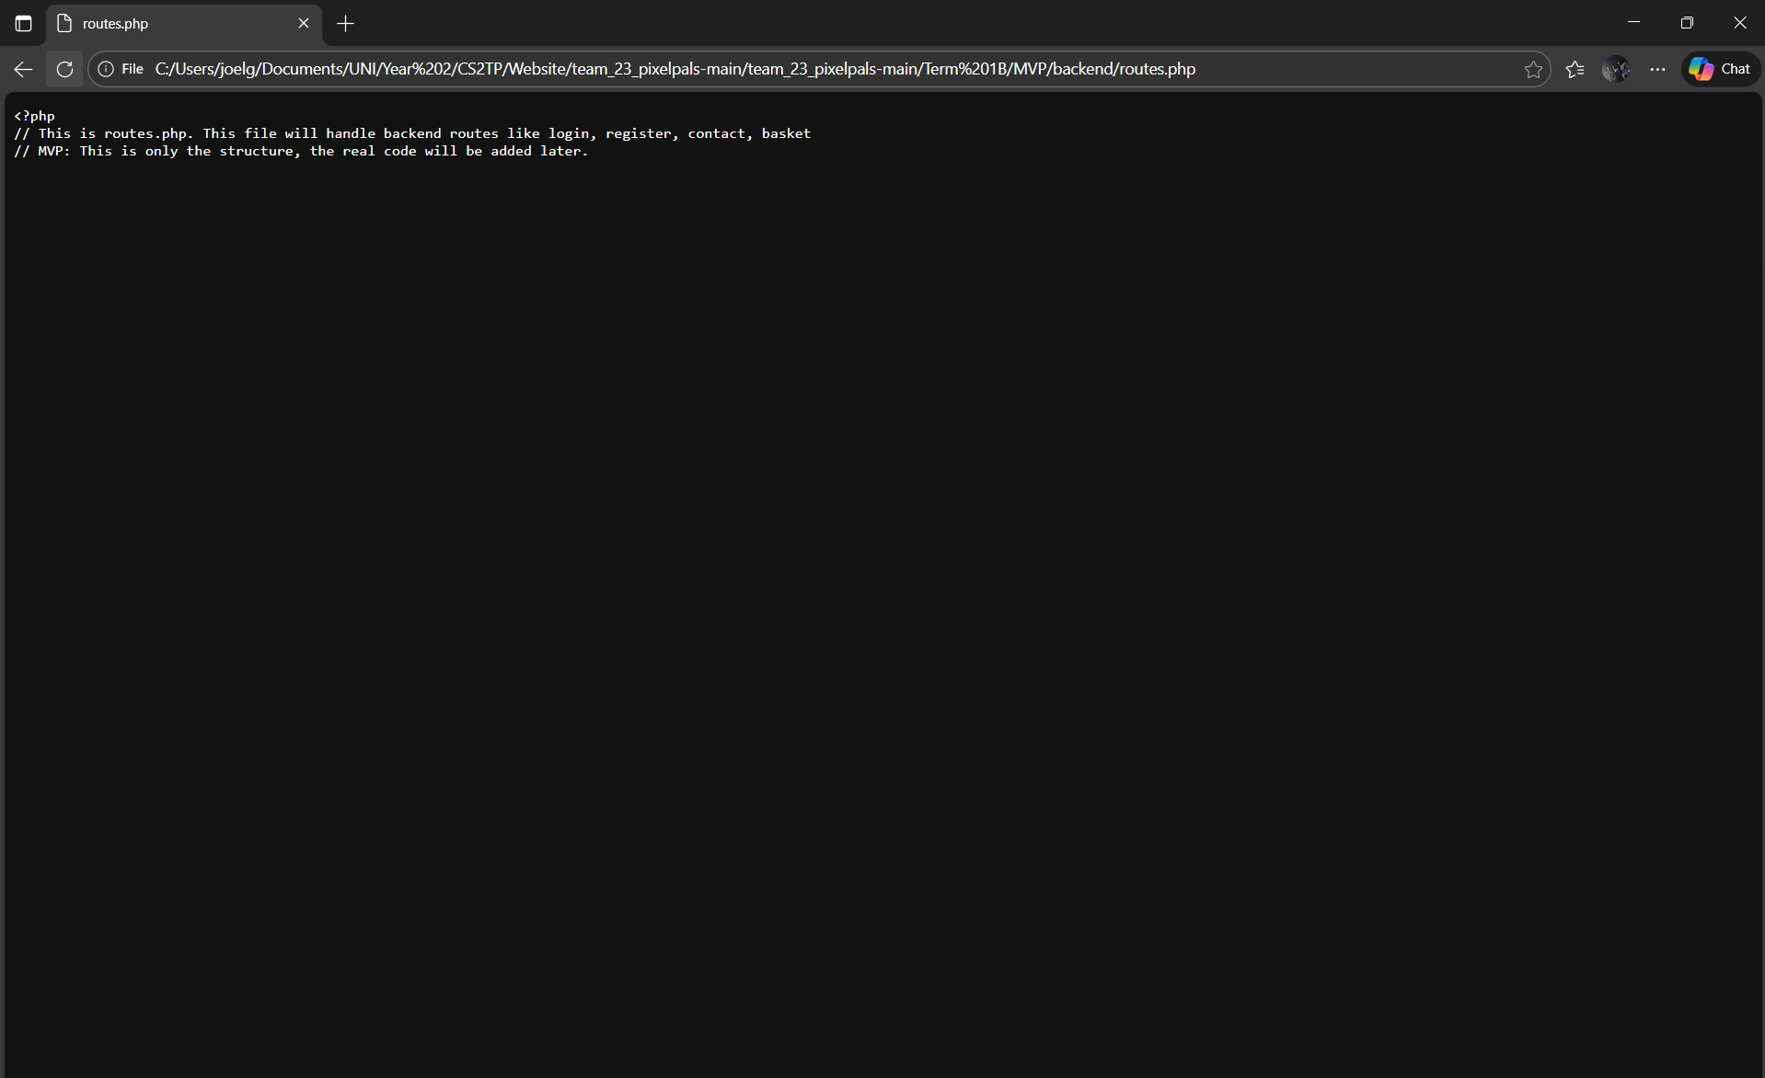

TC5 – Products Page
Steps: Open products.html.
Expected: Products display.
Actual: Products are displayed successfully although the images of the products don’t load.
Status: Bugged
Screenshot: 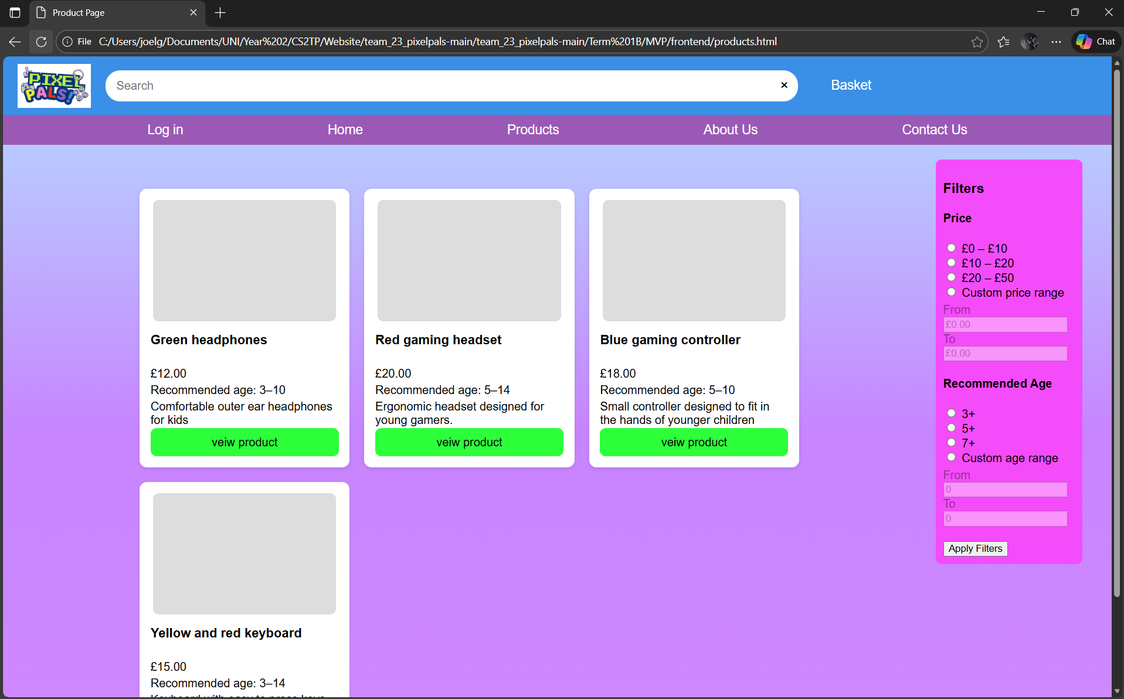

TC6 – Product Page
Steps: Click a product.
Expected: The user will be taken to the page containing the details product that has been clicked on.
Actual: The user directed to the page containing the details of the product although the images of the products are missing.
Status: Working
Screenshot: 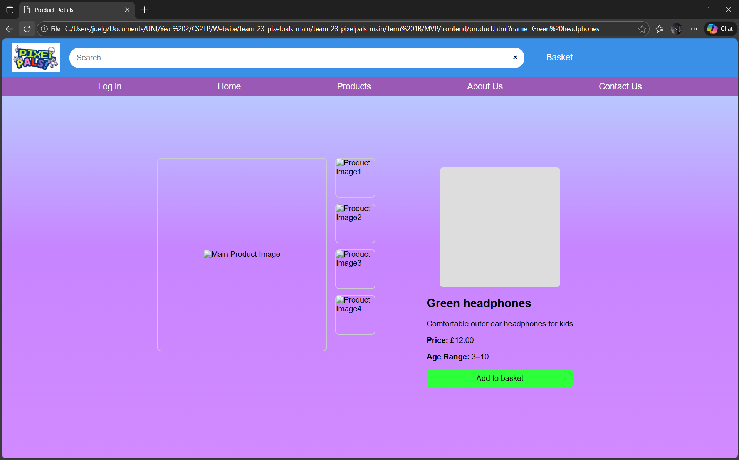

TC7 – Basket Page
Steps: Add item (if functional) and open basket.html.
Expected: Basket updates.
Actual: The basket was accessible but not functional as the ‘Green headphones’ were not added to the basket
Status: Accessinble but not functional
Screenshot: 
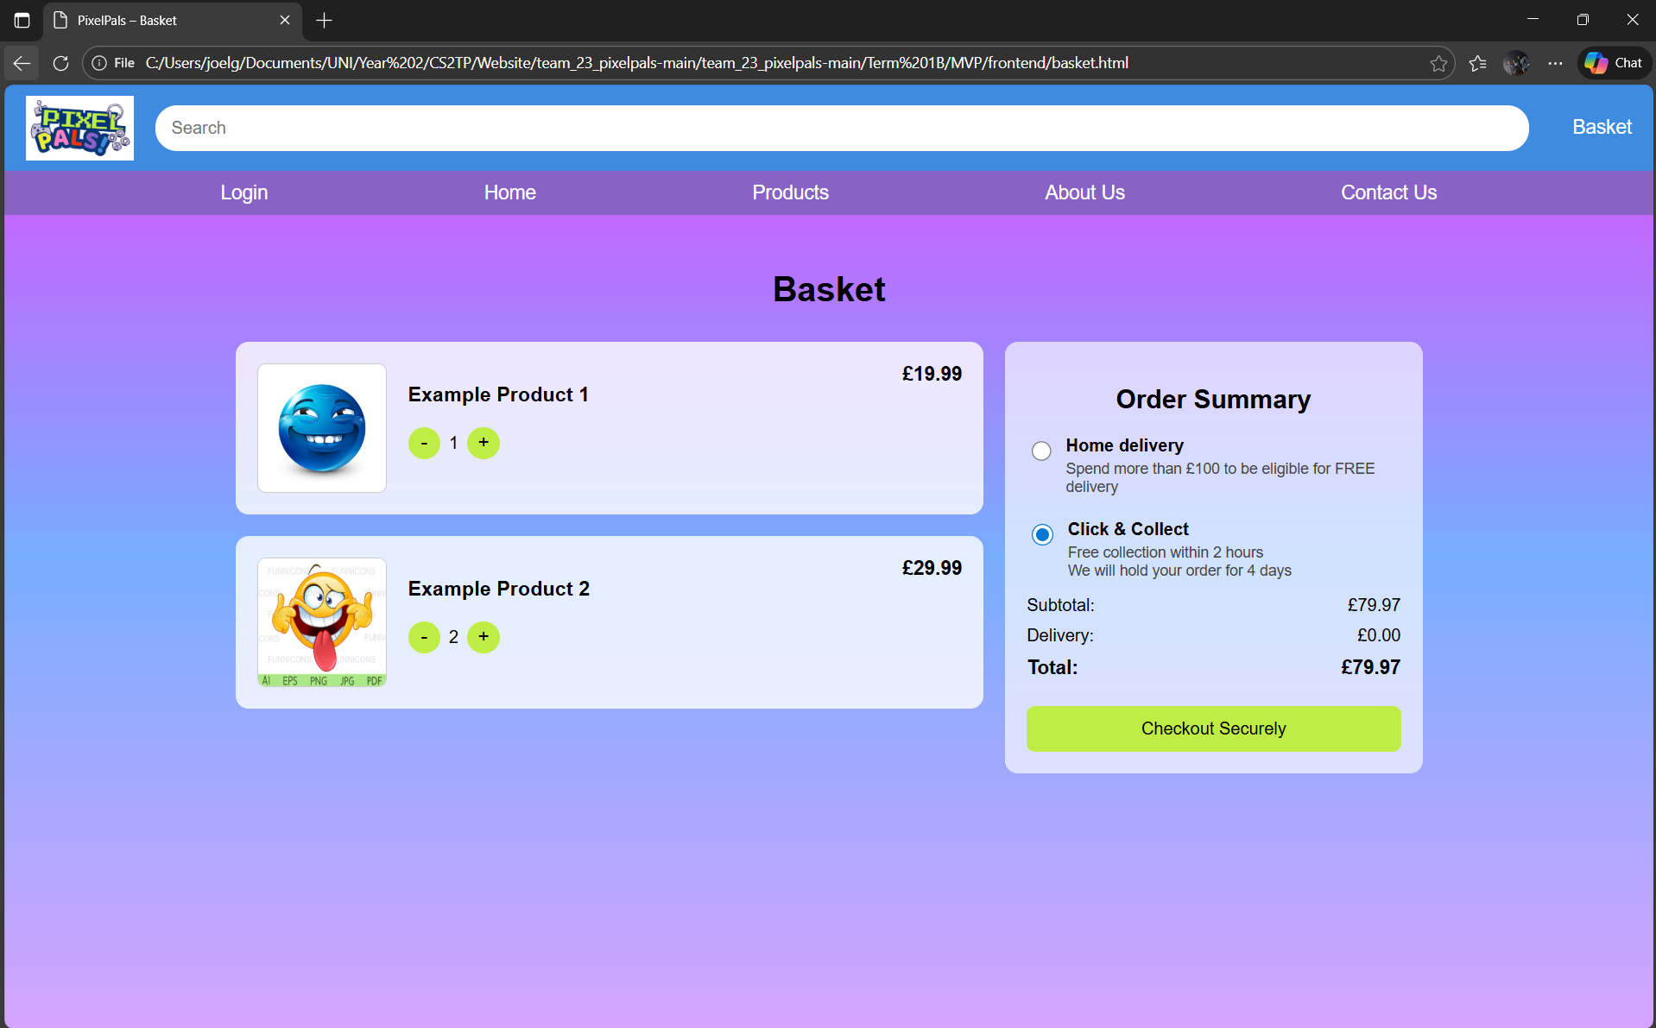

TC8 – Checkout Button
Steps: Click checkout.
Expected: Loads checkout.html.
Actual: The checkout.html loaded successfully
Status:
Screenshot:

4. Bugs Found
- There are two navbars in the in index.html
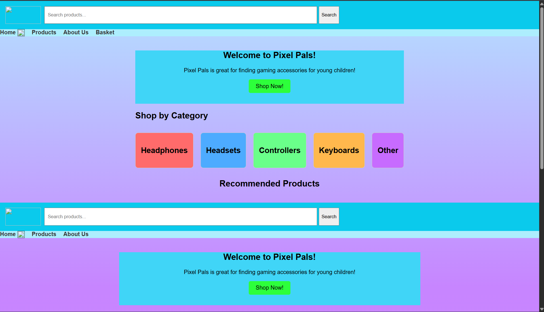

- The logo of the company is missing in the home page/index.html
- The search functionality currently doesn’t work
- The total price isn’t shown on the checkout page


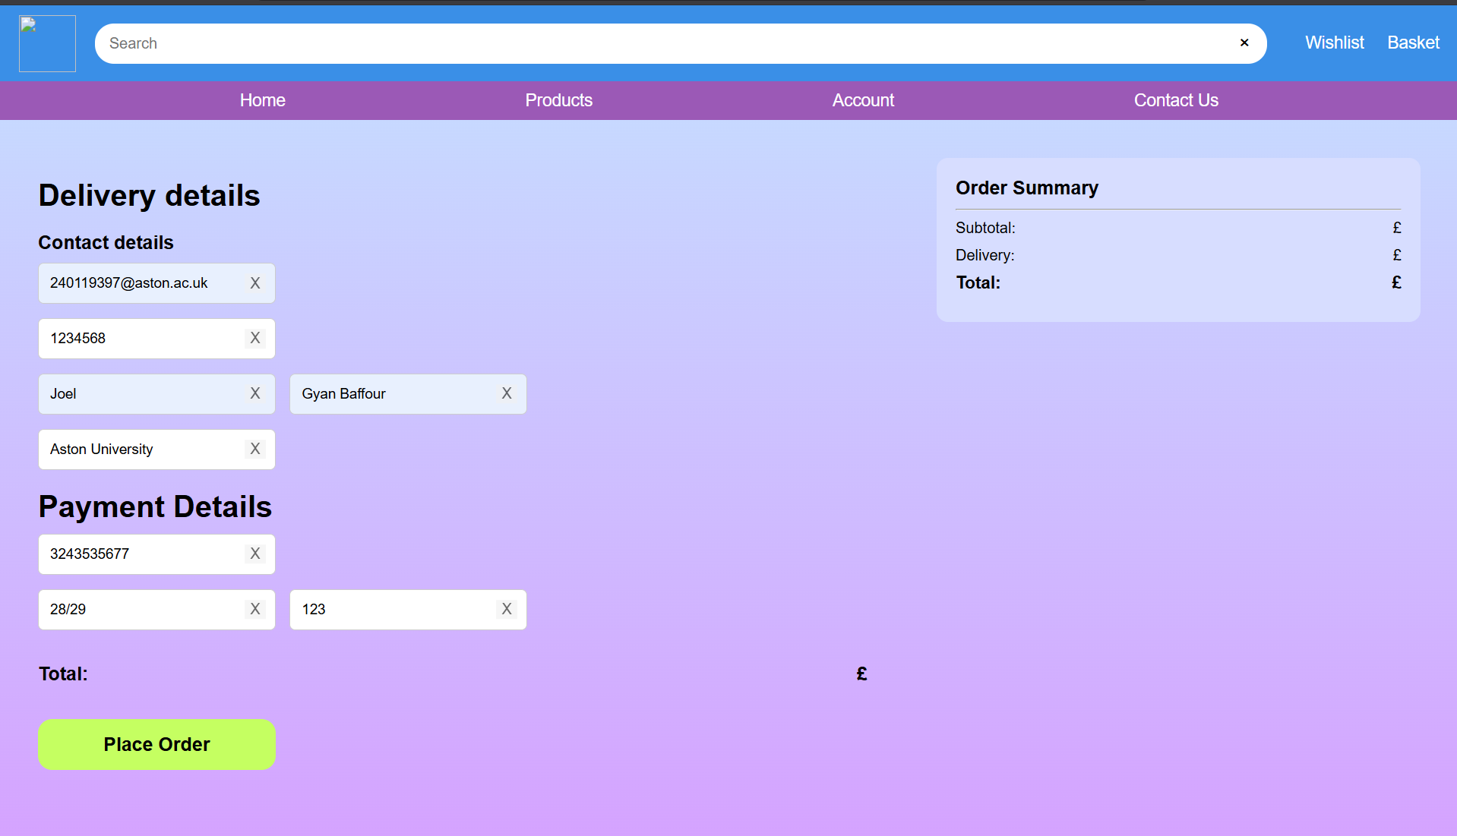

5. Fixes Suggested
These suggestions were reported to Maeesa, Jamaal and Oscar
- Make the design the home page/index.html consistent with the rest of the website in order to match the wireframe
- Get rid of the duplicated elements in the home page/index.html
- Add validation to email and password in register.html and login.html

6. Retesting
Confirm all fixes were retested and passed.
The design of the home page now matches the design shown in the wireframe and is now free from duplicate elements
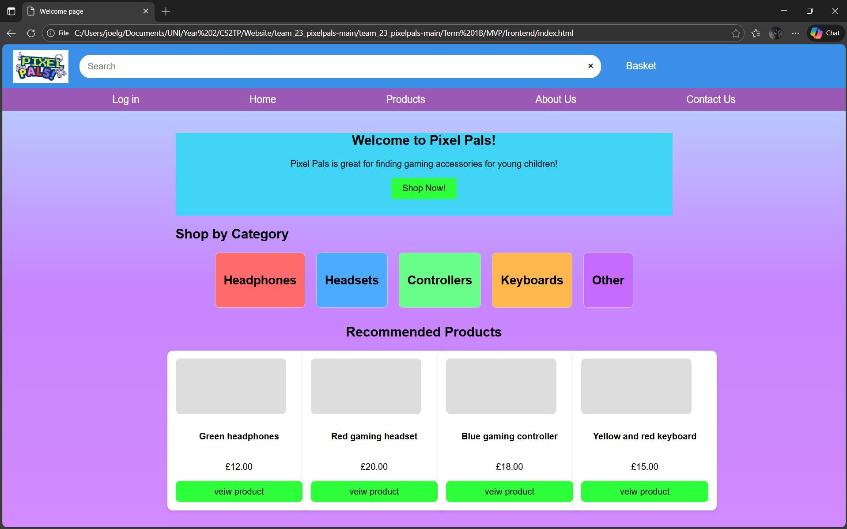
7. Final Summary
All core MVP features functioned as expected. Backend routes received POST data successfully and navigation operated without errors.
The initial system testing performed on the PixelPals MVP indicates that while the backend logic and navigation structure are functional, the application requires some frontend, backend and UI/UX repairs before it is ready for deployment.
The retesting confirms that most bugs and UI/UX inconsistencies have been fixed. The Website still needs some minor backend repairs before it can be deployed and be available to the public
Successes:
- The code has been proven to be stable. The navigation between the links/pages works as expected
- The UI/UX issues were swiftly fixed and now match the wireframe
- The overall website is easy for people of all ages to navigate and use
Failure:
The website has some backend inconsistencies/defects that make the website not ready for deployment. (Some mentioned in TC3 and TC4)

Appendices:













